**Real-Time Fluid Dynamics for Games Report**

http://www.gamerendering.com/category/special-effects/page/2/

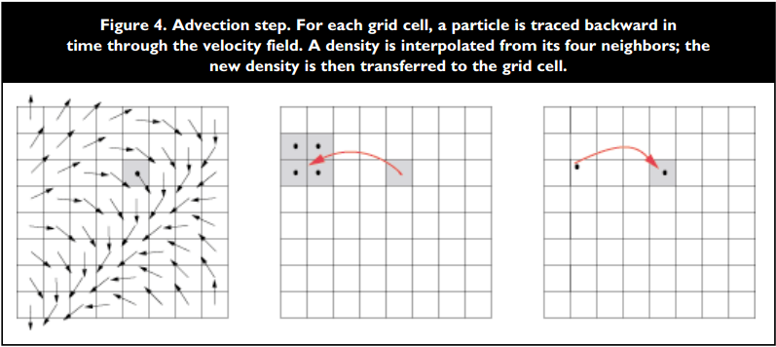

**Projection method (fluid dynamics)**

**The algorithm: two stages**

1. Compute velocity that's not doesn't have the incompressibility constraint

2. Pressure is used to project the intermediate velocity on to a space of divergence-free velocity field

**The Helmholtz-Hodge Decomposition**

any vector v can be decomposed into sets of a basis vector components whose sum is v

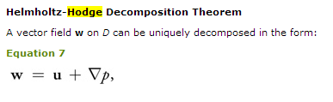

This theorem states that any vector field can be decomposed into the sum of two other vector fields:

1. a divergence-free vector field

2. gradient of a scalar field

**Poisson's equation**

commonly used to model diffusion

incompressible vector field == divergence free vector field

it means it's a vector field v with divergence zero at all points in the field



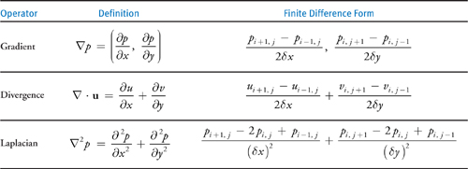

Divergence Finite Difference form in 3D